|  |  |  |  |  |  |  |  |  |  |
| --- | --- | --- | --- | --- | --- | --- | --- | --- | --- |
| Course Title: | ICP | | | | Course Code: | | 103 | Credit Hours: | 4 |
| Lab Instructor: | Usman Ali | | | | Program Name: | | BS(CS)/BSI | | |
| Semester: |  | Batch: |  | Section: | C | | Date: | 14/1/2021 | |
| **Time Allowed:** | **180 minutes** | | | | **Maximum Marks:** | | |  | |
| Student’s Name: | **UMAIR ALi** | | | | Reg. No. | CUI/ FA20-BCS-123 /SWL | | | |
| **Important Instructions / Guidelines:**  *Read the question paper carefully and answer the questions according to their statements.*  *Mobile phones are not allowed. Calculators must not have any data/equations etc. in their memory.*  *Lab tasks will be drawn on the answers books as well as on the simulator for evaluation.* | | | | | | | | | |

**Lab Terminal 2**

Q#1. Ansers the questions 5*10

1. Raising a number n to a power p is the same as multiplying n by itself p times. Write a function called power() that takes a double value for n and an int value for p, and returns the result as a double value. Use a default argument of 2 for p, so that if this argument is omitted, the number n will be squared. Write a main() function that gets values from the user to test this function.
2. Write a function called hms_to_secs() that takes three int values—for hours, minutes, and seconds—as arguments, and returns the equivalent time in seconds (type long). Create a program that exercises this function by repeatedly obtaining a time value in hours, minutes, and seconds from the user (format 12:59:59), calling the function, and displaying the value of seconds it returns.
3. Assume that you want to generate a table of multiples of any given number. Write a program that allows the user to enter the number and then generates the table, formatting it into 10 columns and 20 lines. Interaction with the program should look like this (only the first three lines are shown): Enter a number: 7

7 14 21 28 35 42 49 56 63 70

77 84 91 98 105 112 119 126 133 140

147 154 161 168 175 182 189 196 203 210

1. Write a program that generates the following table:

1990 135

1991 7290

1992 11300

1993 16200

Use a single cout statement for all output.

1. Write a program that check a password.

A:

**Question: Raising a number n to a power p is the same as multiplying n by itself p times. Write a function called power() that takes a double value for n and an int value for p, and returns the result as a double value. Use a default argument of 2 for p, so that if this argument is omitted, the number n will be squared. Write a main() function that gets values from the user to test this function.**

**ANS:**

#include<iostream>

using namespace std;

double power(double,int=2);

int main()

{ int pow;

double n,r;

cout << "please Enter number : ";

cin >> n;

cout << "please Enter exponent : ";

cin >> pow;

r = power(n,pow);

cout << "Result = " <<r<<endl ;

r = power(n);

cout << "here is result without passing exponent is " << r<<endl;

return 0;}

double power(double a, int b)

{double j = 1;

for(int i = 1; i <= b; i++)

j = j* a;

return j;

}

Output:

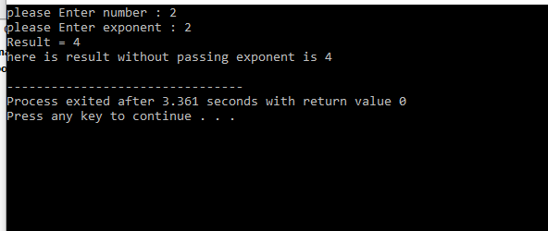

**B:**

**Question: Write a function called hms_to_secs() that takes three int values—for hours, minutes, and seconds—as arguments, and returns the equivalent time in seconds (type long). Create a program that exercises this function by repeatedly obtaining a time value in hours, minutes, and seconds from the user (format 12:59:59), calling the function, and displaying the value of seconds it returns**

ANS:

#include<iostream>

using namespace std;

int hms_to_sec(int hour,int min, int sec);

int main()

{

int hour,min,sec;

///////////////////////////////////////Result///////////////////////////////////////////////////

int result =hms_to_sec(hour,min,sec);

cout << "result = " << result;

system("pause");

return 0;

}

int hms_to_sec(int hour,int min, int sec)

{

int seconds =0;

cout << "enter hours" << endl;

cin >> hour;

cout << " enter minutes" << endl;

cin >> min;

cout << " enter seconds" << endl;

cin >> sec;

seconds = (hour*60*60)+(min*60)+sec;

return seconds;

}

Output:

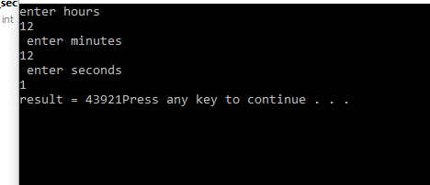

**C :**

**Question: Assume that you want to generate a table of multiples of any given number. Write a program that allows the user to enter the number and then generates the table, formatting it into 10 columns and 20 lines. Interaction with the program should look like this (only the first three lines are shown): Enter a number: 7**

**7 14 21 28 35 42 49 56 63 70**

**77 84 91 98 105 112 119 126 133 140**

**147 154 161 168 175 182 189 196 203 210**

**Ans :**

#include<iostream>

using namespace std;

int main()

{

int number;

cout<<"Enter a number: ";

cin>>number;

int x=1;

for(int i=0;i<20;i++) **//////////For Rows//////**

{

for(int j=0;j<10;j++) **///////////For columns//////**

{ cout<<number*x<<"\t";

x++; }

cout<<endl;

}

return 0;

}

Output:

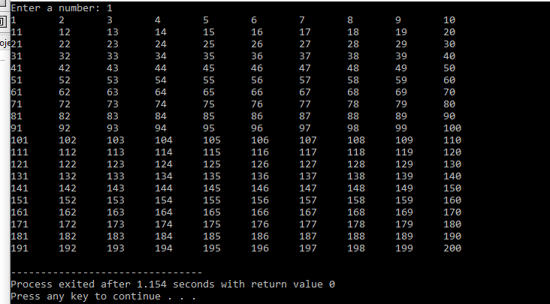

**D**

**Question: Write a program that generates the following table:**

**1990 135**

**1991 7290**

**1992 11300**

**1993 16200**

**Use a single cout statement for all output.**

ANS:

#include<iostream>

using namespace std;

#include<iomanip>

int main() // **single cout statement**

{

**cout**<<1990<<setw(8) << 135 << endl

<<1991 << setw(8) << 7290 <<endl

<<1992<< setw(8) << 11300 <<endl

<<1993 << setw(8) <<16200 <<endl;

return 0;

}

Output:

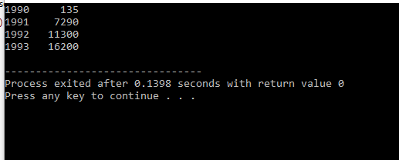

**E:**

#include<iostream>

#include<cstring>

using namespace std;

main()

{

char pas[22]=”umair”;

char pas1[22];

cout<<"Enter your password = ";

cin>>pas1;

if(strcmp(pas,pas1)==0)

{

cout<<"Your Password is correct"<<endl;

}

else

{

cout<<"Your password incorrect "<<endl;

}

system("pause");

}

Output:

